

Angular

Version Upgrade
From 12 to 18

[POST-LLD]
Low Level Design Document
Revalsys

REVISION HISTORY:

Version | Date Modified | Author | Reason for Change
1.0 | 16-04-2025 | Sivalatha | Migration of IIB Application from Angular 12 to 18
1.1 | 28-04-2025 | Ravi Kiran | Added version update from 14 to 18 changes for RevalERP through command and challenges
1.2 | 12-05-2025 | Ravi Kiran | Added version update from 13 to 18 changes for Watchstationindia through command and challenges

This document has been reviewed and accepted:
Version | Date Reviewed | Reviewer Name | Title
1.0

Table of Contents
Table of Contents 3
1. Introduction: 4
1.1 Overview: 4
1.2 Purpose: 4
2. Scope Inclusion: 4
3. Standards, Conventions and Procedures:
3.1 Development Language: 6
3.2 Design/Programming Standards/Naming Conventions: 6
4. Screens / Functionalities / Validations: 6

Introduction:

Overview:
- This document outlines the process, purpose, and standards for upgrading the Angular application from version 12 to 18.

Purpose:
- The primary goals of the upgrade are.
- Ensure compatibility with the latest Angular libraries and ecosystem tools.
- Leverage improved performance and modern framework features.
- Strengthening application security through the latest patches and improvements.

Scope Inclusion:

- This upgrade applies to:
- The core Angular framework and CLI version changes.
- All project dependencies including RxJS, TypeScript, and zone.js etc.
- Deployment configurations impacted by Angular build changes.
- There are two methods to convert the angular application from outdated to latest version.
- 1. Steps Followed to Update the Version:
  - Created a new Angular 18 solution using the command:
ng new IIBHPUI.revalweb.com --standalone false
- Manually added the main.js file. This is required for Angular 18 application server-side run.
- Re-added all previously used packages that are compatible with Angular 18 and updated the script and style file references in the angular.json file.
- Added or updated main files such as index.html, app.component.ts, etc.
- Performed an internal build to verify server-side functionality using the following commands.
    - ng build for building
    - npm run serve:ssr for serving
- After adding all components, the following issues were encountered:
- TypeScript imports issues and form validator errors.
- Resolved import issues by removing outdated imports and adding new ones compatible with Angular 18.
  - Updated form validation structure as per Angular 18 syntax:
    - Previously: formValidations.userName.errors or formValidations.userName.errors.required
    - Now: formValidations['userName'].errors or formValidations['userName'].errors['required']
- Issues Faced During Release:
- Maintained two environment files.
    - One for local development.
    - One for server deployment.
- After releasing, the application was still referencing local URLs.
- To resolve this, configuration settings in the angular.json file were updated accordingly (details provided below)
"configurations": {
"production": {
"budgets": [
{
"type": "initial",
"maximumWarning": "1mb",
"maximumError": "5MB"
}
],
"outputHashing": "all",
"fileReplacements": [
{
"replace": "src/environments/environment.ts",
"with": "src/environments/environment.prod.ts"
}
]
},
"development": {
"optimization": false,
"extractLicenses": false,
"sourceMap": true,
"fileReplacements": [
{
"replace": "src/environments/environment.ts",
"with": "src/environments/environment.ts"
}
]
}
}

- Note:
- The release and build pipelines must be configured for Angular version 18.
- For deployment, remove or comment out the code below in the server.ts file. It performs internal server-side checks, ensure the code below is added or enabled in the server.ts file.
function run(): void {
const port = process.env['PORT'] || 4000;
const server = app();
server.listen(port, () => {
console.log(`Node Express server listening on http://localhost:${port}`);
});
}
run();
2. Command through update:
- Angular recommends upgrading one major version at a time. Skipping major versions can lead to compatibility issues and deprecated APIs.
We'll upgrade through each version in the following sequence:
    - 14 → 15 → 16 → 17 → 18
  - Step-by-Step Upgrade Instructions
    - Step 1: Update Angular CLI Globally (Optional but recommended)
npm install -g @angular/cli
    - Step 2: Upgrade to Angular 15
ng update @angular/core@15 @angular/cli@15
    - Step 3: Upgrade to Angular 16
ng update @angular/core@16 @angular/cli@16
    - Step 4: Upgrade to Angular 17
ng update @angular/core@17 @angular/cli@17
    - Step 5: Upgrade to Angular 18
ng update @angular/core@18 @angular/cli@18

- After Each Upgrade
- Remove node_modules (Remove-Item -Recurse -Force .\node_modules)
- Run npm install (if not done automatically)
- Run ng build to verify the build
- Run the app to test functionality
- Fix any deprecated or breaking changes shown in console/logs
Challenges and Considerations During Upgrade

During the Angular version upgrades (14 → 18), some third-party libraries and tooling may require extra attention:

- ng-multiselect-dropdown
- May have compatibility issues across Angular versions.
- Check for the latest compatible version or consider migrating to a new maintained package if abandoned.
- Review breaking changes if moving from Angular 14 to 18.

- ng-otp-input
- Check for updates that support Angular 16+.
- Otherwise, minor modifications might be required in input handling or event binding.

- @aspnet/signalr / @microsoft/signalr
- SignalR client libraries generally stay backward compatible, but module federation setups may cause import issues.
- If using module federation, ensure SignalR is marked as a shared singleton to avoid runtime conflicts.

- ngx-barcode6
- This package entirely replaced with ngx-barcode and checked with multiple barcode packages for the compatibility.
- Webpack and Module Federation
- Webpack 5+ is mandatory after Angular 15.
- Adjust webpack.config.js or webpack.server.config.js for changes in module federation syntax:
  - ModuleFederationPlugin structure has updated slightly.
  - Dynamic remote loading requires shareScope adjustments.
- Watch for changes in:
  - exposes
  - remotes
  - shared

- Syntax Changes in Angular Code
- Router Enhancements: provideRouter for Standalone applications from Angular 15.
- Signals: Angular 16 introduces Signals (optional) — they can coexist with RxJS.
- HTTPClientModule: Angular 15 introduced withInterceptorsFromDi
  - Starting from Angular 15, when you use bootstrapApplication (instead of traditional AppModule),
HTTP interceptors must be manually included using a helper function.
- In Angular 15+, you no longer have to implement interfaces like CanActivate, CanDeactivate, CanLoad, Resolve, etc.
- If you have many existing guards, you can remove implements manually or use an IDE search-replace across your codebase.
- Below are the packages that will be updated when we are trying to update:
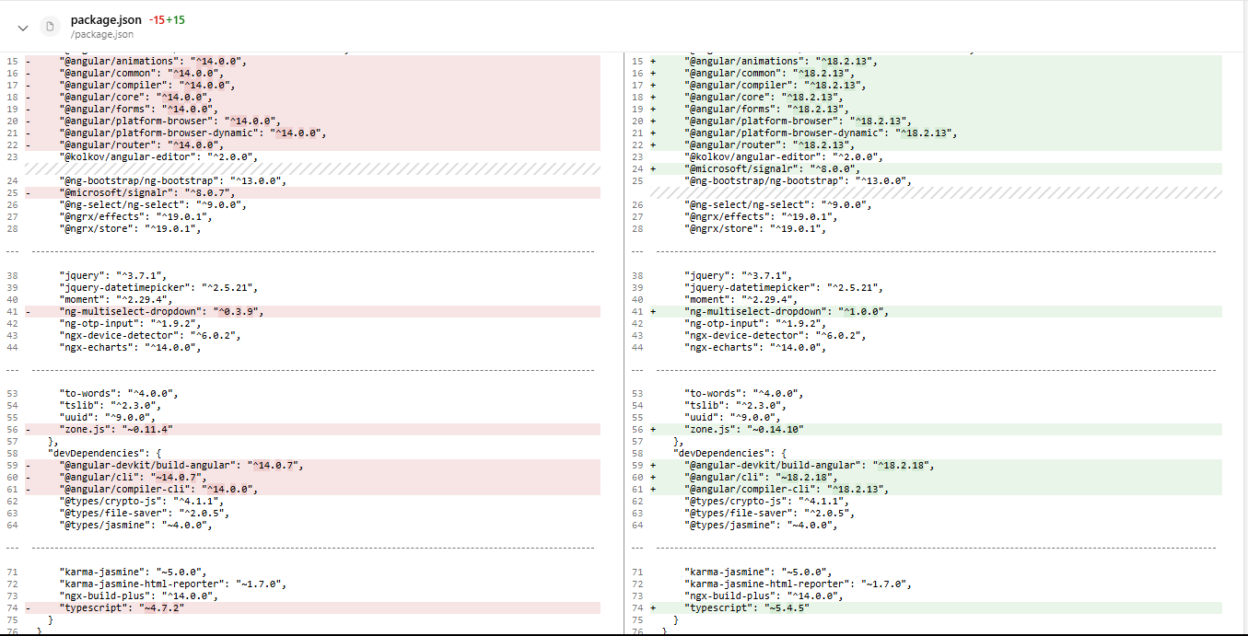

- While converting Watchstationindia application from 14 to 18 versions also we faced below challenges as this application is having many packages.
- Modify server.ts, main.server.ts, and other SSR-related files to align with Angular 18 standards.
- Permanently remove ngx-json-ld and replace it with a custom JSON-LD rendering service.
- Package Updates:
Package Name | Previous Version | Updated Version | Action | Reason for Update / Removal
ngx-cookie | ^5.0.2 | ^6.0.1 | Updated | Compatibility with Angular 18, improved cookie API support.
ngx-infinite-scroll | ^10.0.1 | ^16.0.0 | Updated | Required for Angular 18 and zone-less rendering support.
ngx-slick-carousel | ^0.5.1 | ^17.0.0 | Updated | Ivy and Angular 18 compatibility.
zone.js | ~0.13.3 | ~0.14.10 | Updated | Mandatory for Angular 18.
@types/node | ^12.20.43 | ^22.13.14 | Updated | TypeScript compatibility and updated Node typings.
typescript | ~5.1.6 | ~5.4.5 | Updated | Required by Angular 18 CLI and features.
@angular/ssr | Not Present | ^17.3.17 | Added | New official SSR package introduced by Angular as of v17+.
@nguniversal/express-engine | ^13.0.1 | Removed | Removed | Deprecated in favor of @angular/ssr; not required with new SSR setup.
@nguniversal/builders | ^13.0.1 | Removed | Removed | Builders were removed as SSR integration moved to core Angular tooling.
browser-sync | ^3.0.0 | Unchanged | — | No compatibility issues noted.

- Server-Side Code Changes
- Files Modified:
  - server.ts
  - main.server.ts
  - app.server.module.ts
- Reasons:
  - Align SSR configuration with Angular 18’s platform-server improvements.
  - Support newer render APIs and better error handling.
  - Integration with updated zone.js and @angular/platform-server.
- Library Replacement: ngx-json-ld
- Removed Package: ngx-json-ld (deprecated and no longer maintained)
- Replacement: Custom service for structured data (JSON-LD) rendering.
- Reason for Change:
  - The ngx-json-ld library was incompatible with Angular 18 SSR and had limitations in dynamic rendering of JSON-LD content. A custom Angular service was created to inject structured data dynamically into the DOM for SEO and schema.org support.
- SSR Architecture Changes (Angular 17 Migration)
- With Angular 17, SSR underwent a major transformation with the introduction of the @angular/ssr package. Here's what changed:
- Removed
  - @nguniversal/express-engine
  - @nguniversal/builders
- Added
  - @angular/ssr: Official Angular SSR package replacing Universal.
- Codebase Changes
  - server.ts: Refactored to use the new @angular/ssr APIs.
  - main.server.ts: Modified to remove reliance on Universal-specific engine functions.
  - angular.json: SSR build and serve configurations updated to use new Angular CLI-native SSR setup.
  - Builders (@nguniversal/builders:ssr-dev-server, @nguniversal/builders:prerender) were replaced by Angular CLI equivalents.

3. Standards, Conventions and Procedures:

3.1 Language Development:
Typescript, Angular 18.

3.2 Design/Programming Standards/Naming Conventions:
Camel case.

4. Screens / Functionalities / Validations:

- After updating the version
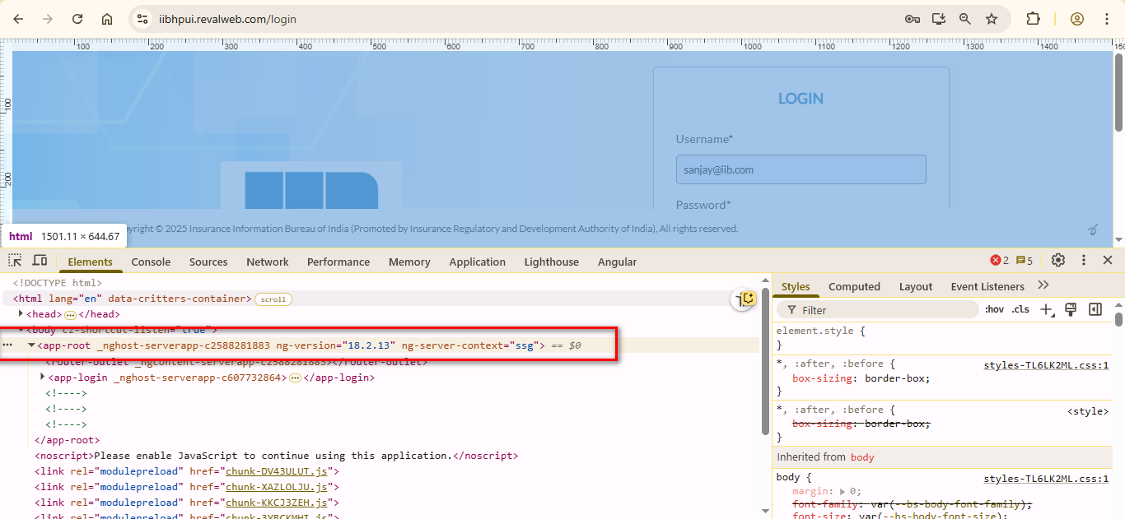

RevalERP:

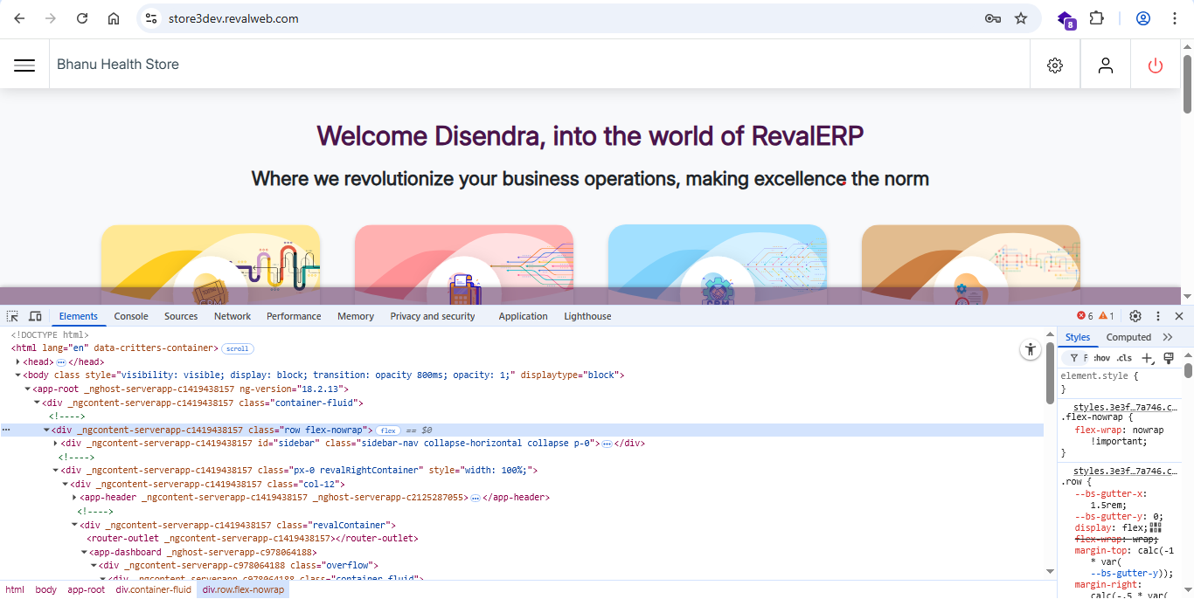

Watchstationindia:

